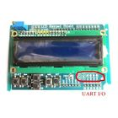**1602 LCD Board Keypad Shield Blue Backlight For Arduino with UART Interface**

**1602 LCD Board Keypad Shield Blue Backlight For Arduino with UART Interface**

[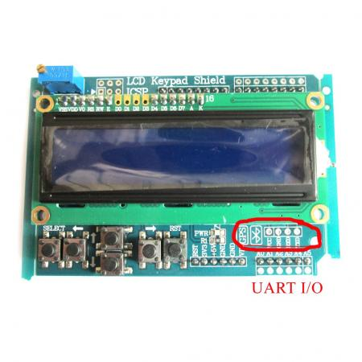](http://img.inkfrog.com/click_enlarge1.php?image=IMG_1738______1.jpg&username=jelly0115&aid=372758433)

Click to Enlarge

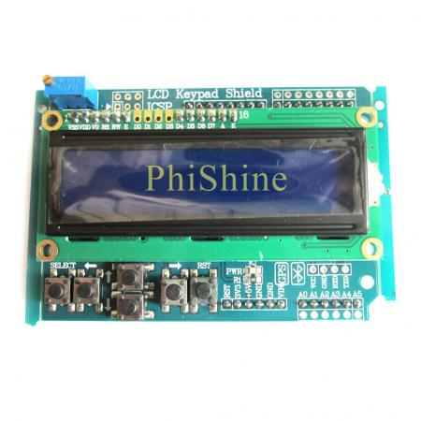

Click to Enlarge

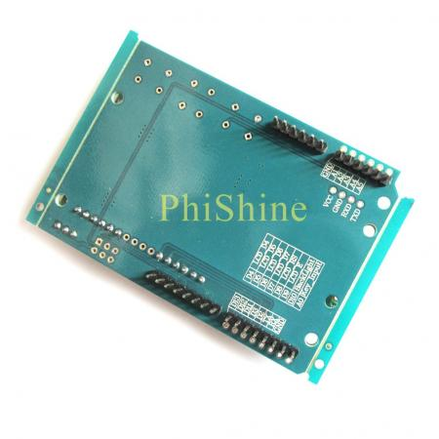

Click to Enlarge

**Description:**

**With UART I/O, can Connect Bluetooth GPS Module.**

**Description :**

1 . The choice of two lines of 16 characters blue backlight 1602

2 . Using 4 -bit format data driver saves IO

3 .Set the contrast adjustment potentiometer

4 . Set the backlight control pin , the software can open, close, or adjust the backlight brightness

5 . Leads to the UART serial interface for connecting a Bluetooth module , GPS and other serial devices

6 .With the completion of an analog input port 5 keys, use the patch buttons for easy mass production factory

7 . Set a reset button , set aside ICSP interface , IO interfaces unused reserved